Welcome to St James
If you are new please fill in a Welcome Card at the back of the church. Thank you. Join us for coffee in the hall after our 10am service to say hello, everyone is very welcome.

Gluten free communion wafers are available.
Please speak to one of the Churchwardens or the Sides people before the service.

Hymns: 671,794,724,682,664,650

This year's APCM is Sunday 10th May. We are always looking for PCC members. If you feel you would like to contribute to the work of St James and would like to enrol you can speak to Fr Darren, the Churchwardens or any of current PCC members to find out more.

PCC minutes for February are available on the notice board at the back of the church.

Due to the May Bank Holiday, the next Contemplative Prayer Group meeting will be on Monday 11th May at 11am, in the St Cross Chapel. All are welcome. More information available from Fr Darren.

You are invited to attend the Collation of Father Hugo by the Bishop, as he is formally collated as Vicar of St Michael’s and All Angels. The service will take place tomorrow 27th April at 6.00pm.
Walsingham Pilgrimage 2027
A pilgrimage has been organised for Friday 25th to Monday 28th June 2027. This will be for full board, travelling by coach. Depending on numbers, price could be anywhere between £325 and £412 p/p (obviously the more we get the less £s it will be).This includes dinner (Fri), breakfast, lunch, dinner (Sat-Sun), breakfast (Mon), accommodation, coach travel, and share of driver's accommodation. Deadline for interest and £40 deposit 5th June 2026. If we get minimal interest we may have to cancel coach and make our own travel plans, or cancel the trip altogether as it won't be cost effective for us to go. For more details please speak to Bridget Wade.

26th April 2026

Fourth Sunday of Easter
Sunday 10am Sung Mass
Wednesday 10am Said Mass

PLEASE PRAY FOR:-
The King and Queen and all people in positions of public office at local and national level.
Our Bishops: Jonathan and Matthias of our link diocese of Ho.

Within Our Deanery: Holy Spirit and all those living and working in Southsea.
We pray for Anthony Bridgeport being Baptised today.

We pray at mass for the Acutely ill and those who care for them: Geoff and Yvonne Sowerby, Margaret Day, David Gorman, Janet Fowlds, Jerry Knowles, David Buckett, Fr Tony Upton, Jean Simmonds, Keith Hewitt, Kevin and Sue McNally, Marty Udy, Dawn, Gary Day, Colin Philpott, Joseph Tyler, Ken Baker, Karen Brooks, Dorrie Eyres, Jill Chalmers and Dave Knowles
We pray for the Long term sick and those who care for them at Morning and Evening Prayer: Jeremy Clifton, Joan Gray, Adrian, Sue Warren-Holland, Helen,Ted Trott.

Recently Departed: Sharon Timmins
Year’s mind: Mary Lipscomb, Arthur Eaton, Dorothy Smith (28), Stanley Mortimore, Muriel Macleod, Dorrie Crout (29), Reginald Robinson, Raymond Denton, Judith Eastland (30), William Wright, Gwendoline Butler (2)

You can donate to St James Church here
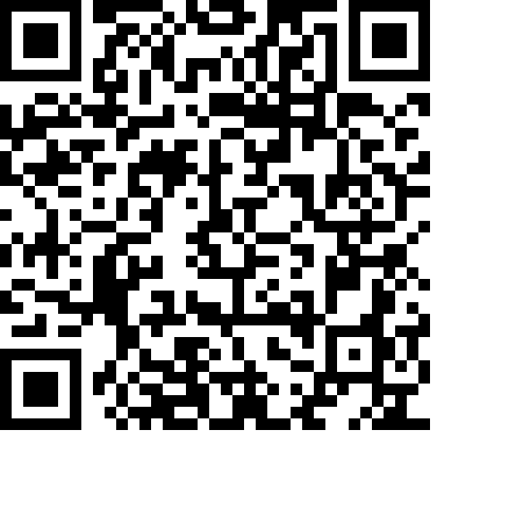

Parish Safeguarding Officer
Alison Threlkeld,
Mob: 07900082509 alison.e.threlkeld@gmail.com
A copy of our Parish Safeguarding Policy is on the church notice board.

Fr Darren 023 9307 0921, fr.darrenacourt@gmail.com. His usual day off is Friday he would be grateful to be spared all but emergency calls on this day. Thank you.

